Name: Abdurrahman Qureshi

Roll no: 210451

EXPERIMENT 13

Q.) WAP to implement MIDPOINT CLIPPING ALGORITHM

CODE

#include<stdio.h>

#include<conio.h>

#include<graphics.h>

void main()

{

int

a[10][10],x1,y1,x2,y2,xwmin=100,ywmin=100,

xwmax=300,ywmax=300,x,y,i;

int gd,gm;

clrscr();

detectgraph(&gd,&gm);

initgraph(&gd,&gm,"C:\\TC\\BGI");

printf("Enter co-ordinates of line\n");

for(i=0;i<2;i++)

{

printf("x%d y%d \n",i+1,i+1);

scanf("%d%d",&a[i][0],&a[i][1]);

}

rectangle(xwmin,ywmin,xwmax,ywmax);

line(a[0][0],a[0][1],a[1][0],a[1][1]);

getch();

cleardevice();

if(a[0][0]<xwmin&&a[1][0]>xwmin)

{

x1=a[0][0];

y1=a[0][1];

x2=a[1][0];

y2=a[1][1];

do

{

x=(int)(x1+x2)/2;

y=(int)(y1+y2)/2;

if(x<xwmin)

{

x1=x;

y1=y;

}

}

while(x!=xwmin);

a[0][0]=x;

a[0][1]=y;

}

rectangle(xwmin,ywmin,xwmax,ywmax);

line(a[0][0],a[0][1],a[1][0],a[1][1]);

getch();

if(a[0][0]<xwmax&&a[1][0]>xwmax)

{

x1=a[0][0];

y1=a[0][1];

x2=a[1][0];

y2=a[1][1];

do

{

x=(int)(x1+x2)/2;

y=(int)(y1+y2)/2;

if(x<xwmax)

{

x1=x;

y1=y;

}

else

{

x2=x;

y2=y;

}

}

while(x!=xwmax);

a[1][0]=x;

a[1][1]=y;

}

cleardevice();

rectangle(xwmin,ywmin,xwmax,ywmax);

line(a[0][0],a[0][1],a[1][0],a[1][1]);

getch();

else

}

{

x2=x;

y2=y;

}

OUTPUT:

BEFORE CLIPPING:
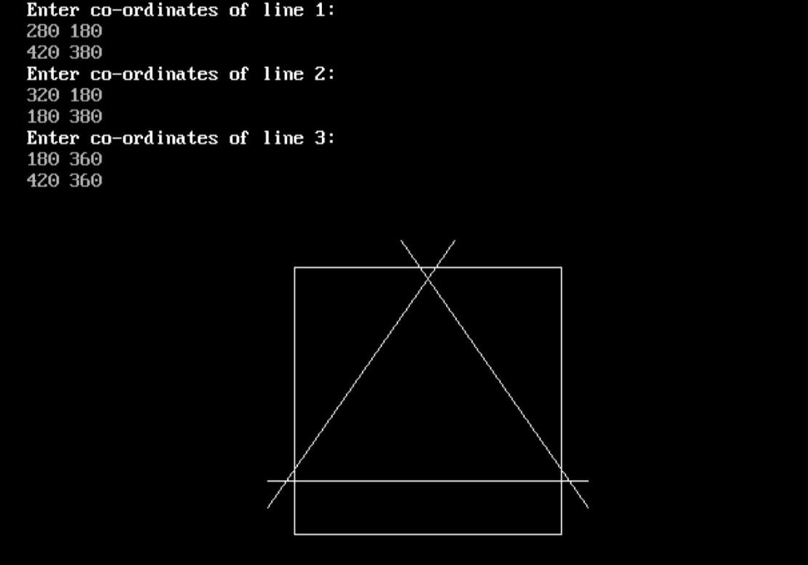

AFTER CLIPPING:
